Algebra 1: Unit 3, Lesson 2

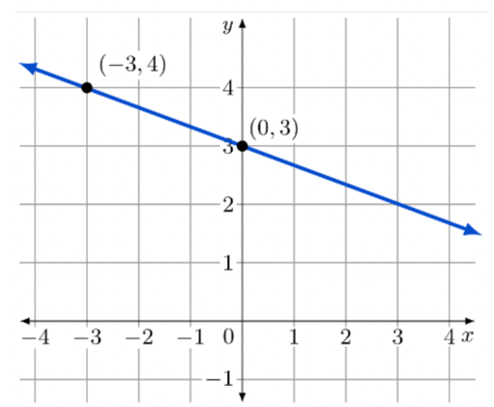
- The graph of a line is shown.

Find the slope of the line using the points $(0, 3)$ and $(-3, 4)$.
Slope = $\frac{Change in y}{Change in x}$
Slope = _______
$$-\frac{1}{3}$$

- The graph of a line is shown.
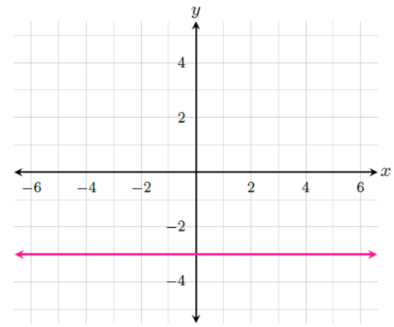
The slope of the line is __________.
0

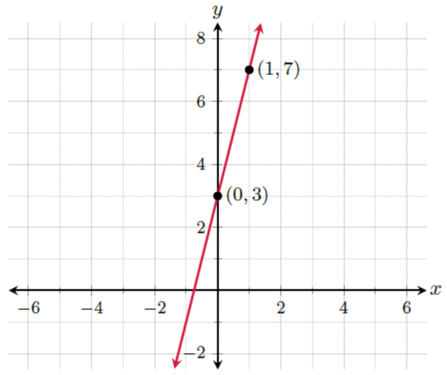
- The graph of a line is shown.

What is the equation of the line, in point-slope form?

$$y-7=4(x-1)$$

